Predicting Customer Churn in the Telecommunications Industry

Sherrell Bacon
Bellevue University

Predicting Customer Churn in the Telecommunications Industry
Business Problem
Customer churn presents a significant financial challenge for telecommunications companies, as acquiring new customers is substantially more expensive and complex than retaining existing ones. Understanding why customers leave and identifying those at highest risk of churn enables organizations to implement proactive retention strategies. This project focuses on predicting customer churn using historical customer data and translating analytical findings into actionable, business-focused recommendations that can improve customer retention and long-term revenue stability.
Background and History
Customer churn analysis has long been a core application of predictive analytics within subscription-based industries such as telecommunications, banking, and software-as-a-service. Advances in machine learning have enabled organizations to move beyond descriptive reporting toward predictive and prescriptive analytics. Telecommunications companies, in particular, generate large volumes of customer behavioral and billing data, making churn prediction a well-suited use case for data science. Prior research and industry practice indicate that contract type, tenure, pricing, and service quality are among the most influential factors affecting customer retention.
Data Explanation
The dataset used in this analysis is the Telco Customer Churn dataset from Kaggle, initially provided by IBM Sample Data Sets. Each row represents an individual customer, and each column captures demographic information, subscribed services, account details, or churn status.

Data Preparation
Data preprocessing included converting the `TotalCharges` variable to a numeric format and imputing missing values using a domain-informed approach. Missing `TotalCharges` values were imputed by multiplying customer tenure by monthly charges, reflecting standard telecommunications billing practices. An indicator variable was retained to flag imputed values for transparency. Categorical variables were standardized to remove inconsistencies such as leading or trailing whitespace.
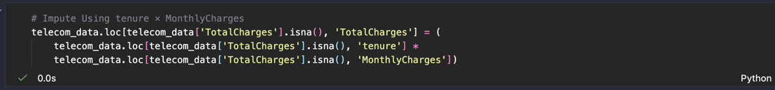
Methods. This project followed an end-to-end data science process consisting of exploratory data analysis, preprocessing, model development, and evaluation.
Exploratory Data Analysis (EDA). EDA was conducted to identify trends and relationships between customer attributes and churn behavior. Visualizations were used to examine churn rates across contract types, tenure levels, service subscriptions, and billing methods.
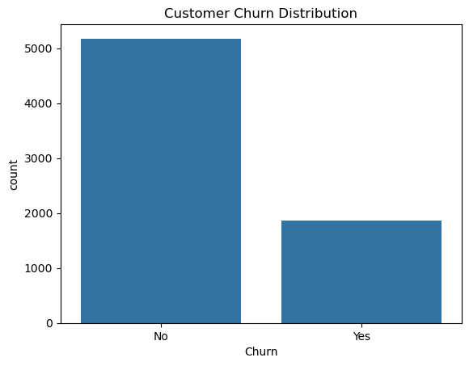
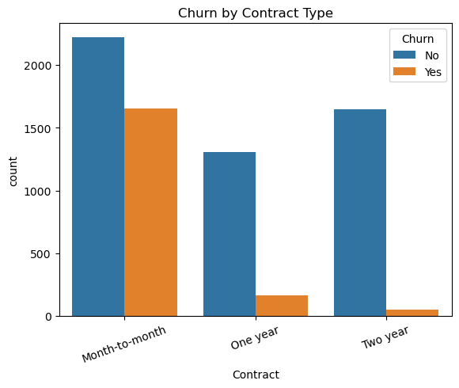
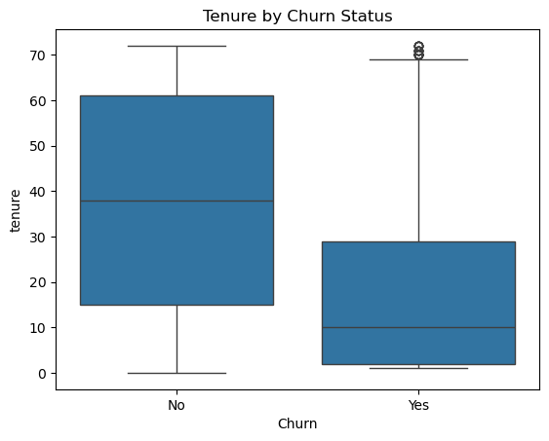
Modeling Techniques. Multiple classification algorithms were developed and evaluated to assess predictive performance and tradeoffs between interpretability and accuracy. The models implemented included logistic regression, decision tree classifiers, and random forest classifiers. A unified preprocessing pipeline was created using one-hot encoding for categorical variables and standardization for numerical variables to ensure consistent feature treatment across models.
Class imbalance was addressed through the use of class-weighted loss functions, prioritizing recall for churned customers due to the higher business cost of failing to identify at-risk customers. Model performance was evaluated using accuracy, precision, recall, F1-score, and ROC-AUC metrics. While multiple models were tested, logistic regression was selected as the final model due to its strong performance and superior interpretability for business stakeholders.
Analysis. The logistic regression model achieved an overall accuracy of 74% and an ROC-AUC score of 0.84, indicating strong predictive capability. The model demonstrated a recall of 78% for churned customers, meaning that the majority of customers who left were correctly identified. Key predictors of churn included customer tenure, monthly charges, and contract type. Customers on month-to-month contracts, with higher monthly charges and shorter tenure, were significantly more likely to churn.
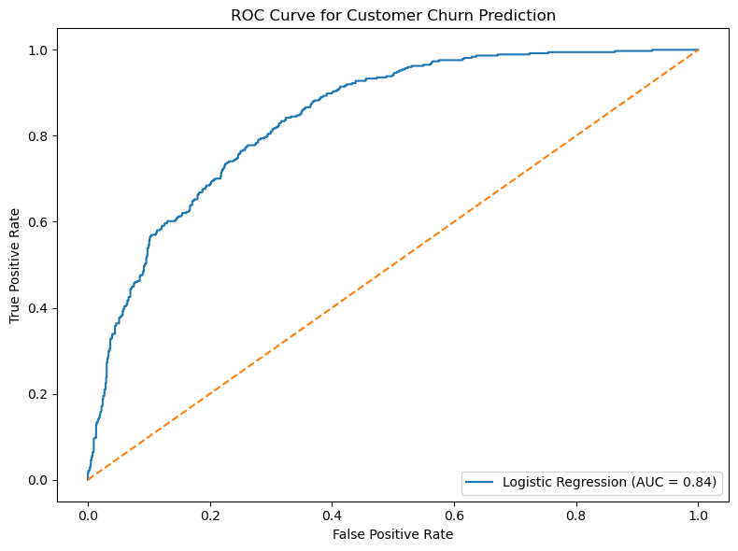
The results demonstrate that customer churn can be effectively predicted using readily available customer data. While no model can perfectly predict churn, the developed approach provides valuable insights that allow organizations to identify high-risk customers and intervene proactively. The findings underscore the importance of long-term contracts, competitive pricing, and effective customer support services in mitigating churn.
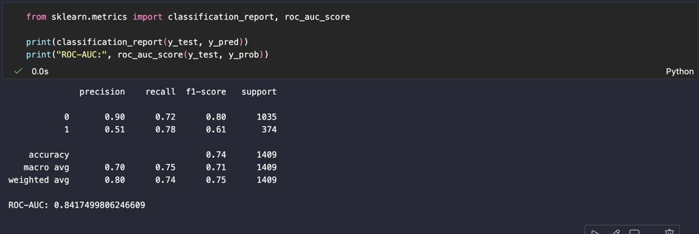
Assumptions
This analysis assumes that historical customer behavior is indicative of future behavior and that the dataset accurately represents real-world telecommunications customers. It is also assumed that billing structures remain relatively stable over time.
Limitations
The dataset represents a single telecommunications provider and may not generalize to all markets or customer segments. Additionally, the data is cross-sectional rather than time-series, limiting the ability to model churn dynamics over time.
Challenges
Key challenges included handling class imbalance, preprocessing a large number of categorical variables, and striking a balance between model interpretability and predictive performance.
Future Uses and Additional Applications
Future work could incorporate customer interaction data, such as support tickets or service outages, to enhance predictive accuracy. Advanced techniques such as gradient boosting or survival analysis could also be explored.
Recommendations
Telecommunications companies should prioritize retention efforts for customers on month-to-month contracts and those with short tenures. Incentives such as discounted long-term contracts, bundled services, or enhanced technical support may reduce churn rates.
Implementation Plan
The predictive model can be deployed as a customer risk-scoring tool integrated into customer relationship management systems. Marketing and retention teams can use churn risk scores to target proactive outreach campaigns.
Ethical Assessment
Ethical considerations encompass ensuring customer privacy, preventing discriminatory targeting, and maintaining transparency in the application of predictive models to business decisions. Models should be used to support customers rather than penalize them.
Appendix A: Supporting Documentation
The appendix includes data preprocessing scripts, exploratory data analysis visualizations, and model evaluation outputs. All code used in this analysis is available via a GitHub repository and attached.
Questions an Audience Might Ask
1. Why was recall prioritized over precision for churn prediction?
2. How does class imbalance affect model performance?
3. Can this model be applied to other industries?
4. What is the business cost of false positives versus false negatives?
5. How often should the model be retrained?
6. Which features had the most significant influence on churn?
7. How does this model integrate with existing business systems?
8. What ethical risks exist when using customer data?
9. How scalable is this approach for larger datasets?
10. What additional data would improve prediction accuracy?

References
Kaggle. (2017). Telco Customer Churn. Www.kaggle.com. https://www.kaggle.com/datasets/blastchar/telco-customer-churn

